RV COLLEGE OF ENGINEERING®, BENGALURU-560059

(Autonomous Institution Affiliated to VTU, Belagavi)



**Herzberg’s Two Factor Theory**

**Contemporary Theory of Motivation: Adam’s Equity theory**

PROJECT REPORT

***Submitted by***

|  |  |
| --- | --- |
| **MANOJ KUMAR B V** | 1RV23CS407 |

**Under the Guidance of**

**Dr. Sandhya S**

**Associate Professor**

**Department of Computer Science and Engineering**

**R.V College of Engineering**

***in partial fulfilment for the requirement of 5th Semester***

***PRINCIPLES OF MANAGEMENT AND ECONOMICS(HS251TA)***

**Academic Year 2024-25**

RV COLLEGE OF ENGINEERING®, BENGALURU-560059

(Autonomous Institution Affiliated to VTU, Belagavi)



**CERTIFICATE**

Certified that the project work titled **Herzberg’s Two Factor Theory, Contemporary Theory of Motivation: Adam’s Equity theory,** is carried out by Manoj Kumar BV (1RV23CS407),who is a bonafide student of R. V. College of Engineering, Bengaluru, in partial fulfillment of the curriculum requirement of 5th Semester ***Principles of Management and Economics (HS251TA)*** during the academic year **2024-2025**. It is certified that all corrections/suggestions indicated for the internal Assessment have been incorporated in the report.

**Signature of Faculty In-charge                                                       Head of the Department**

**Dept. of CSE, RVCE**

**ACKNOWLEDGEMENT**

I would like to express our sincere gratitude to **K.N. Subramanya,** Principal of **R.V. College of Engineering**, for providing us with the opportunity and resources to work on my project, ***Herzberg’s Two factor Theory, Contemporary theories of Motivation: Adam’s Equity theory*** Their encouragement and support have been invaluable in shaping this research.

I extend my heartfelt thanks to **Dr. Shanta Rangaswamy,** Head of the Department of **Computer Science and Engineering**, for their continuous guidance and insightful feedback, which helped us refine our ideas and enhance our project.

I would like to thank **Dr. Sandhya S, Associate Professor,** for their unwavering support, valuable suggestions, and guidance throughout the project. Their expertise and constructive feedback have played a crucial role in our learning process and in making this project a success.

**ABSTRACT**

Herzberg’s Two-Factor Motivation Theory classifies employee motivation into two categories: motivation factors (e.g., achievement, recognition, responsibility, and growth) and hygiene factors (e.g., company policies, salary, supervision, and working conditions). The theory suggests that while the absence of hygiene factors causes dissatisfaction, their presence does not enhance motivation. In contrast, motivation factors directly influence employee motivation. This study aimed to test Herzberg’s theory using quantitative research on 162 white-collar municipal employees in Turkey. A Likert scale and percentage distribution analysis were employed to assess the relevance of these factors. The results partially supported Herzberg’s theory, as hygiene factors like salary, company policy, and work conditions were found to be significant motivators, while motivation factors such as responsibility and recognition played a lesser role than expected. Interestingly, salary's motivating effect decreased as workers’ average income increased.

Additionally, Adams’ Equity Theory was examined, which proposes that employees assess workplace fairness by comparing their input-output ratios with those of their peers. Inputs include skills, time, and effort, while outputs encompass salary, status, and promotions. Employees perceive inequity when their contributions do not align with their rewards, leading to demotivation and decreased productivity. The study highlights the importance of fairness in employee satisfaction and behavior, reinforcing that employees who feel equitably treated exhibit higher motivation and performance.

**Table of Contents**

|  |  |
| --- | --- |
|  | Page  NO: |
| Acknowledgement | i |
| Abstract | ii |
|  |  |
| Introduction |  |
| Herzberg’s Two Factor Theory | 1 |
| Case Study | 4 |
| Adam’s Equity theory | 5 |
| Case Study | 8 |
| Conclusion | 10 |
| References | 11 |

**List Of Figures**

|  |  |  |
| --- | --- | --- |
| Figure No. | Figure Name | Page  NO: |
| 1 | Image of Motivators and Hygiene Factors | 3 |
| 2 | Herzberg’s Two Factor- Motivators, Hygiene Factors | 3 |
| 3 | Herzberg’s Theory Terminologies | 4 |
| 4 | Applications of Equity Theory | 6 |

**INTRODUCTION**

In the realm of organizational behavior and management, understanding employee motivation is a critical aspect of fostering a productive, engaged, and satisfied workforce. Motivated employees contribute not only to the success of an organization but also to a positive workplace culture, improved performance, and lower turnover rates. Given the complexities of human behavior, various theories have been developed to explain what drives employees to perform at their best. Among these, Herzberg’s Two-Factor Theory and Adam’s Equity Theory stand out as influential models that provide valuable insights into employee motivation and workplace dynamics.

Herzberg’s Two-Factor Theory, also known as the Motivation-Hygiene Theory, suggests that employee satisfaction and dissatisfaction are influenced by two distinct sets of factors: motivators (intrinsic factors) and hygiene factors (extrinsic factors). While motivators, such as recognition, achievement, and career growth, drive employees toward higher performance and job satisfaction, hygiene factors, such as salary, company policies, and working conditions, primarily prevent dissatisfaction but do not necessarily enhance motivation. This theory underscores the importance of creating an environment where employees are not only satisfied with their basic working conditions but also provided with opportunities for growth and self-fulfilment.

In contrast, Adam’s Equity Theory focuses on the role of fairness in employee motivation. It posits that employees evaluate their work contributions and rewards in comparison to their peers. When individuals perceive an imbalance—whether they are under-rewarded or over-rewarded—they experience distress, which affects their motivation and job performance. Employees who perceive fairness in their compensation, recognition, and opportunities tend to be more engaged and committed to their roles, whereas perceived inequities can lead to dissatisfaction, reduced effort, or even turnover.

By examining these two theories in depth, this report explores their principles, practical applications, and implications for contemporary organizational management. Understanding the interplay between intrinsic and extrinsic motivation, as well as the psychological impact of perceived fairness, enables organizations to design more effective strategies for employee engagement and retention.

**Herzberg’s Two Factor Theory**

**Overview**

Herzberg’s Two-Factor Theory, also known as the Motivation-Hygiene Theory, was developed by Frederick Herzberg in the 1950s. The theory posits that there are two distinct sets of factors that influence employee motivation and job satisfaction: hygiene factors and motivators.

**Hygiene Factors**

Hygiene factors, also known as extrinsic factors, are elements of the job environment that can cause dissatisfaction if they are absent or inadequate. However, their presence does not necessarily lead to long-term satisfaction or motivation. These factors include:

* Company Policies and Administration: Clear, fair, and consistent policies can prevent dissatisfaction.
* Supervision: Effective and supportive supervision can mitigate dissatisfaction.
* Working Conditions: Safe, comfortable, and well-equipped work environments are essential.
* Salary: Competitive and fair compensation prevents dissatisfaction.
* Interpersonal Relations: Positive relationships with colleagues and supervisors can reduce dissatisfaction.
* Job Security: Assurance of continued employment can prevent anxiety and dissatisfaction.

**Motivators**

Motivators, also known as intrinsic factors, are elements related to the nature of the work itself and the opportunities it provides for personal growth and fulfillment. These factors lead to higher levels of job satisfaction and motivation. They include:

* Achievement: Opportunities to achieve and be recognized for accomplishments.
* Recognition: Acknowledgment and appreciation for contributions and successes.
* Work Itself: Engaging and meaningful work that provides a sense of purpose.
* Responsibility: Increased autonomy and responsibility in one’s role.
* Advancement: Opportunities for career growth and progression.

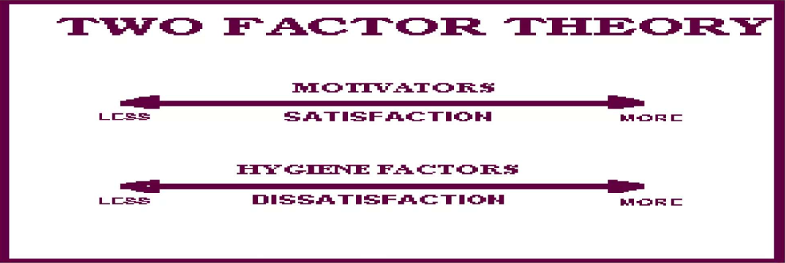

Figure 1 Image of Motivators and Hygiene Factors

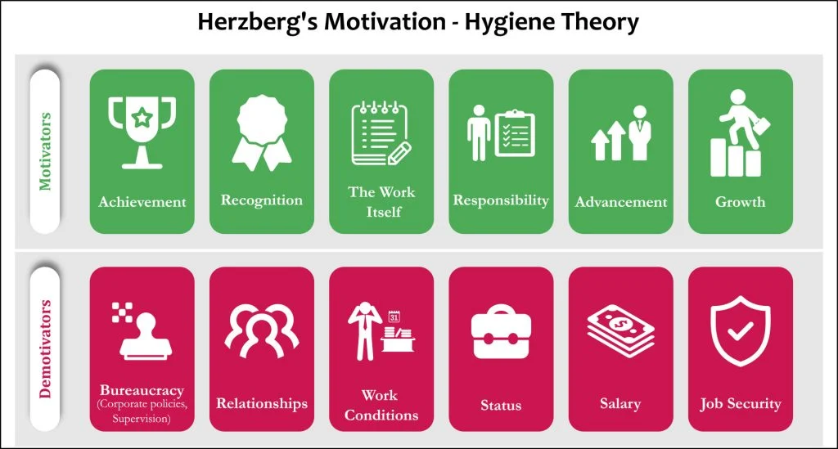

Figure 2 Herzberg's Two Factor - Motivators, Hygiene Factors

**Applications of Herzberg’s Theory**

To apply Herzberg’s Two-Factor Theory effectively, organizations must focus on both hygiene factors and motivators. Here are some practical steps:

1. Assess Hygiene Factors: Conduct regular assessments to ensure that hygiene factors are adequately addressed. This includes evaluating company policies, supervision quality, working conditions, salary structures, and job security.
2. Enhance Motivators: Create opportunities for employees to experience achievement, recognition, meaningful work, responsibility, advancement, and personal growth. This can be achieved through job enrichment, career development programs, and recognition initiatives.

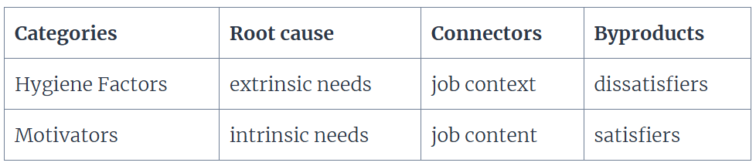

Figure 3 Herzberg's Theory Terminologies

**Case Study: Google’s Approach to Employee Motivation**

Google is renowned for its innovative and employee-centric approach to motivation. The company’s work environment exemplifies Herzberg’s Two-Factor Theory in action. Google provides excellent hygiene factors, such as competitive salaries, comprehensive benefits, and state-of-the-art workspaces. Additionally, the company places a strong emphasis on motivators by offering challenging and meaningful projects, opportunities for career advancement, and a culture of recognition and appreciation.

**Adam’s Equity Theory**

**Overview**

John Stacey Adams' Equity Theory, developed in the 1960s, posits that employees are motivated by fairness in the workplace. According to this theory, individuals compare their inputs (effort, skills, experience) and outcomes (salary, recognition, benefits) to those of others. If they perceive an imbalance, they may experience feelings of inequity, which can affect their motivation and behavior.

**Inputs, Outcomes, and Comparison**

Inputs: What employees contribute to their jobs (e.g., time, effort, skills).

Outcomes: What employees receive in return (e.g., salary, benefits, recognition).

Comparison: Employees compare their input-outcome ratio to that of their peers.

Example: If an employee works long hours (input) but receives the same salary as a colleague who works fewer hours, they may perceive inequity.

When employees perceive inequity, they may respond in several ways:

* Reduce Inputs: Decrease effort or productivity.
* Seek Increased Outcomes: Request a raise or promotion.
* Change Perception: Rationalize the inequity.
* Leave the Organization: Seek employment elsewhere.

**Application in Workplace**

Organizations can apply Equity Theory by ensuring that rewards and recognition are distributed fairly. Transparent communication about pay scales and performance evaluations can help reduce perceptions of inequity.

Example: A company that conducts regular salary reviews and provides clear criteria for promotions can help maintain a sense of fairness among employees.

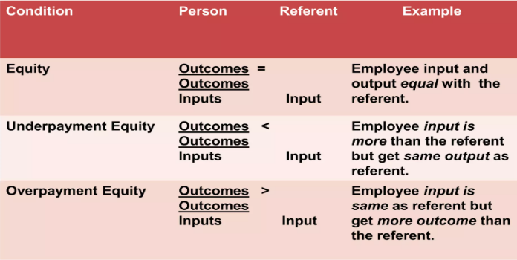

Figure 4 Applications of Equity Theory

**Three Assumptions of Equity Theory**

* Equity Form: Employees anticipate a fair return for what they contribute to their jobs
* Social Comparison: Employees define what their equitable return should be after comparing their inputs and outcomes with those of their coworkers
* Cognitive Distortion: Employees who perceived themselves as being in an inequitable situation will seek to reduce the inequity either by distorting inputs and/or outcomes in their own minds by directly altering inputs and/or output, or by leaving the organization.

**Applications of Adam’s Equity Theory**

Adams' Equity Theory is widely applied across various fields, including organizational psychology, economics, relationships, consumer behavior, and cross-cultural studies.

1. Workplace & Employee Motivation:

* Fair treatment in rewards and promotions boosts job satisfaction and performance.
* Perceived inequity leads to negative behaviors like reduced effort or even workplace theft.
* Employees perform better when effort and rewards are perceived as fair.

1. Economic & Business Decision-Making:

* Wage-Effort Hypothesis: Employees reduce effort or leave jobs when wages seem unfair.
* CEO underpayment affects company value, while overpayment has little impact.
* Perceived unfair taxation can lead to tax evasion.

1. Personal & Social Relationships:

* Fairness in relationships leads to happiness and stability.
* Unequal power in relationships can cause dissatisfaction, but some still prefer having more power.
* Perceived unfair treatment may lead to distress or coping mechanisms like denial and victim-blaming.

1. Consumer Behavior & Information Systems:

* Customers are more likely to engage in repeat purchases when pricing and online transactions are perceived as fair.
* Justice in digital interactions (e.g., online reviews, refunds) affects customer trust and brand loyalty.
* Ethical concerns over technology misuse influence user behavior.

1. Cross-Cultural Applications:

* Fairness perception varies across cultures—some value equity more than others.
* Collectivist cultures (e.g., China, South Korea) perceive fairness differently than individualist cultures (e.g., the U.S.).
* Different cultures react differently to pay inequities and job rewards.

**Strengths and Criticism**

Strengths: Explains motivation beyond financial incentives. Helps organizations design fair compensation and reward systems. Provides insight into workplace behavior, job satisfaction, and employee engagement.

Criticism: Too simplistic – individual perception of fairness varies greatly. Ignores psychological and emotional factors beyond equity (e.g., intrinsic motivation). Does not always account for differences in personality, culture, or social norms.

**Case Study: Pay Equity and Employee Behavior – The Walmart Gender Pay Gap Lawsuit**

**Introduction**

Pay equity has been a long-standing issue in organizations worldwide. A well-known real-world example related to Adams' Equity Theory is the Walmart gender pay discrimination lawsuit, one of the largest class-action lawsuits in U.S. history. The case illustrates how perceived inequity in pay and workplace treatment can lead to widespread dissatisfaction, reduced motivation, and legal action.

The lawsuit, *Dukes v. Walmart Stores, Inc.*, was filed in 2001 by Betty Dukes and a group of female employees who alleged that Walmart systematically paid women less than men for the same work and provided fewer opportunities for promotion. The case gained significant attention as it reflected broader concerns about workplace equity and the implications of perceived injustice.

**Background of the Case**

Walmart, one of the largest retail chains globally, has over 2 million employees. Despite its prominence, the company has faced numerous criticisms regarding its employment practices. The *Dukes v. Walmart* lawsuit alleged that:

Women were paid less than men in the same positions, even after accounting for tenure and job performance.

Women faced fewer promotion opportunities, often being passed over for management roles in Favor of male colleagues.

There was no standardized pay or promotion system, allowing store managers to make subjective decisions, which often favoured men.

The plaintiffs argued that this treatment created a culture of inequity that violated both Walmart's corporate policies and federal anti-discrimination laws.

**Application of Adams’ Equity Theory**

Adams' Equity Theory suggests that employees compare their inputs (effort, skills, tenure) and outputs (salary, promotions, benefits) to those of their colleagues. When employees perceive unfair treatment, they experience distress and take action to restore balance.

1. Perceived Inputs vs. Outputs

The female employees at Walmart believed they put in the same level of effort and skill as their male counterparts but received lower compensation and fewer promotions. This perceived inequity led to widespread dissatisfaction, legal action, and negative publicity for the company.

1. Employee Reactions to Inequity

According to Equity Theory, when individuals perceive unfair treatment, they respond in different ways:

* Reduced Motivation and Performance**:** Employees who felt underpaid or overlooked for promotions became less engaged in their work, leading to decreased productivity.
* Increased Turnover**:** Many female employees sought employment elsewhere, resulting in high attrition rates.
* Legal Action**:** The lawsuit itself was an attempt to restore equity by demanding back pay and changes to Walmart’s policies.

**Court Proceedings and Outcomes**

In 2011, the U.S. Supreme Court ruled against the plaintiffs, stating that they could not sue as a class-action group because Walmart’s pay and promotion decisions were made at the local level, not by a central policy. Despite the setback, thousands of individual lawsuits were filed, some of which resulted in settlements. Walmart later revised its policies to improve gender diversity in management and create clearer pay structures.

**Conclusion**

The *Dukes v. Walmart* case serves as a real-world example of how perceived inequity in pay and promotion opportunities can lead to employee dissatisfaction, turnover, and legal consequences. Adams' Equity Theory explains why employees react negatively when they feel they are being treated unfairly

**Conclusion**

Herzberg’s Two-Factor Theory and Adam’s Equity Theory provide valuable insights into employee motivation and workplace satisfaction. Herzberg’s theory highlights the importance of both hygiene factors, which prevent dissatisfaction, and motivators, which drive performance and job satisfaction. Organizations must balance these elements to create a productive and engaged workforce.

Similarly, Adam’s Equity Theory emphasizes the significance of fairness and perceived equity in the workplace. Employees compare their inputs and outcomes to those of others, and any perceived imbalance can lead to dissatisfaction or decreased motivation. Ensuring fair compensation, recognition, and opportunities for growth is crucial in maintaining employee morale and commitment.

By integrating these theories into organizational strategies, businesses can foster a positive work environment, enhance job satisfaction, and improve overall performance. Understanding the interplay between motivation and fairness helps leaders make informed decisions that support employee well-being and organizational success.

**References**

1. Adams, J. S. (1963). "Towards an Understanding of Inequity." The Journal of Abnormal and Social Psychology, 67(5), 422–436.
2. Adams, J. S. (1965). "Inequity in Social Exchange." In L. Berkowitz (Ed.), Advances in Experimental Social Psychology (Vol. 2, pp. 267–299). New York: Academic Press.
3. Adams, J. S., & Freedman, S. (1976). "Equity Theory Revisited: Comments and Annotated Bibliography." In L. Berkowitz & E. Walster (Eds.), Advances in Experimental Social Psychology (Vol. 9, pp. 43–90). New York: Academic Press.
4. Herzberg, F., Mausner, B., & Snyderman, B. B. (1959). The Motivation to Work (2nd ed.). New York: John Wiley & Sons.
5. Herzberg, F. (1966). Work and the Nature of Man. Cleveland: World Publishing.
6. Herzberg, F. (1968). "One More Time: How Do You Motivate Employees?" Harvard Business Review, 46(1), 53–62.